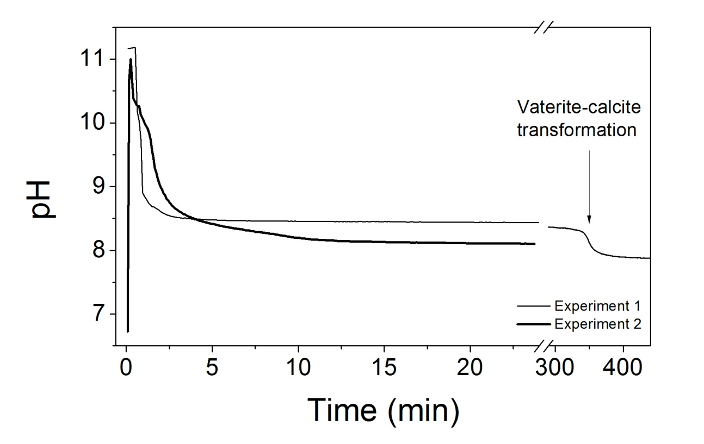
Figure S1: Evolution of the pH as a function of time for experiments 1 and 2.

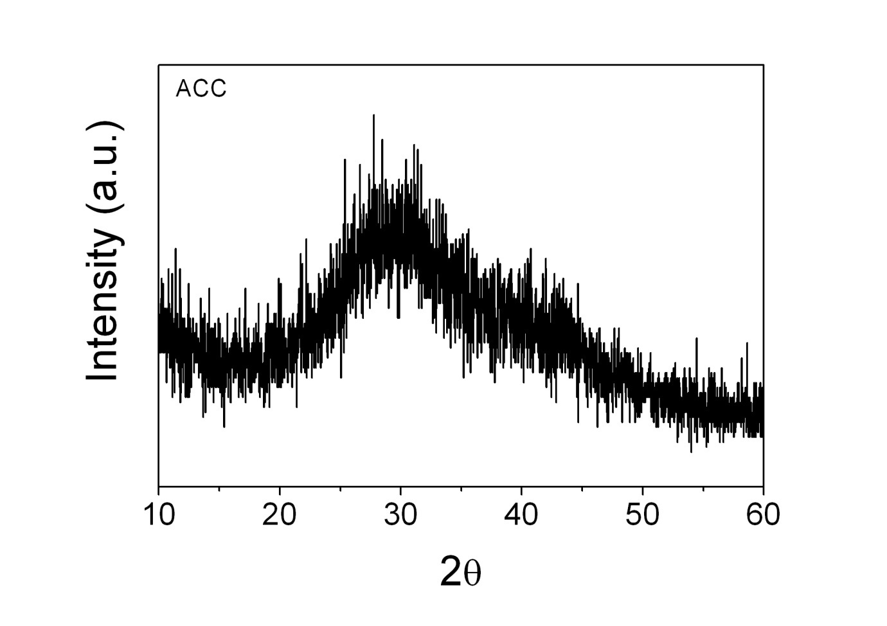
Figure S2: Representative XRD pattern of ACC obtained immediately after mixing of solutions in all experiments.
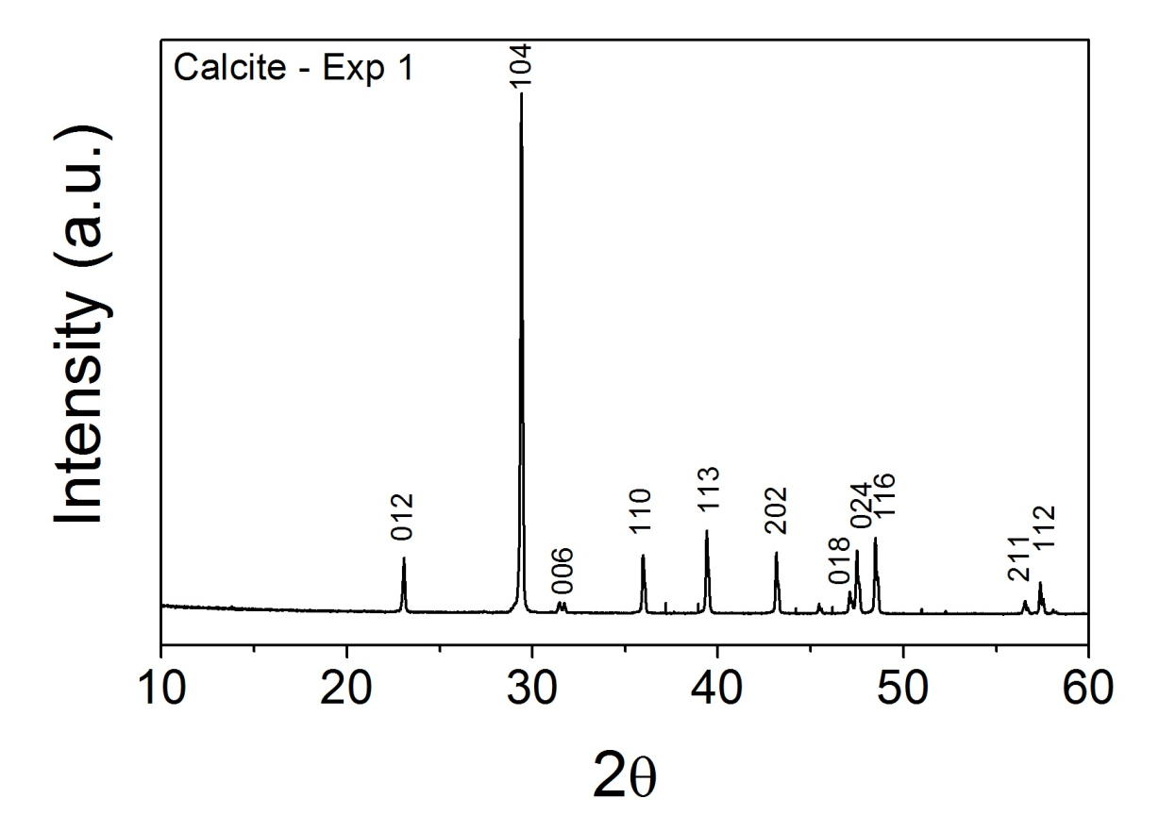
Figure S3: XRD pattern of calcite obtained as a final product in experiment 1.
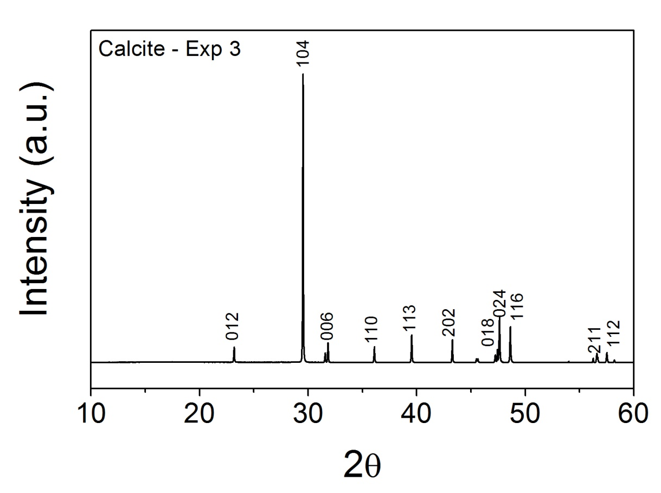

Figure S4: XRD pattern of calcite obtained as a final product in experiment 3.

Figure S5: Photomicrograph of calcite crystals obtained as an end product of experiment 1.

