**Post workshop Galapagos excursion**

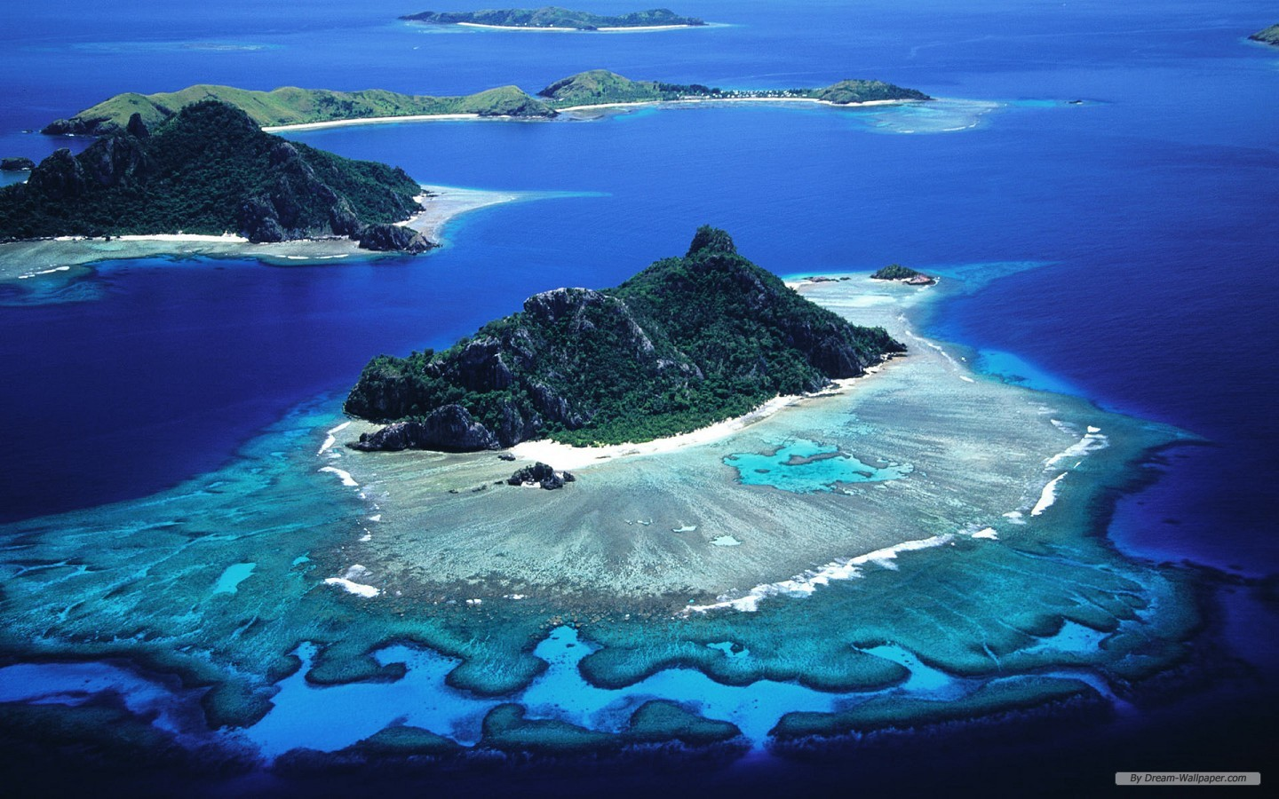

Nov. 14    Transfer and Flight to Baltra, Santa Cruz. Visit Highlands (Twin Craters & Tunnels). Lunch. Afternoon snorkel and beach time at Garrapateros beach. Lodging at Galapagos Suites (Tourist Superior***) or similar

Nov. 15    Speed boat to Isabela island. After lunch Visit the Wall of Tears, Flamingo lake, Tortoise center and other spots. Afternoon snorkeling. Lodging at Casa Marita (Tourist Superior***) or similar

Nov. 16    Full Day Sierra Negra & Volcan Chico. Optional afternoon Snorkeling. Lodging at Casa Marita (Tourist Superior***) or similar

Nov. 17    Transfer back to Santa Cruz and back to the airport for flight to Quito.

**Price per person based on a double basis $940 with a minimum 10 people.**

Private tour Includes:

Airport pick up in Quito

All transportation in Galapagos

Lodging on a double basis

All meals starting with Lunch and ending with breakfast

Bilingual Naturalist guide

IG Tour Leader

Snorkel gear

**Does Not Include:**

Park entrance fees $125

Flight Quito- Galapagos- Quito (Current price @$510)

Personal spending and Tips